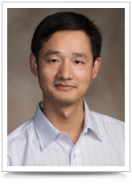

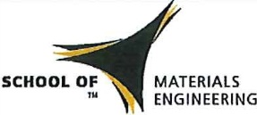**PURDUE**

U N I V E R S I T Y

**MSE SEMINAR**

Prof. Jinsong Huang

Associate Professor

Department of Mechanical and Materials Engineering

University of Nebraska Lincoln

***“Scaling of Diffusion Length in Organometal Trihalide Perovskites for Solar Cell Application and Beyond”***

**Abstract**

The research of organometal trihalide perovskite solar cells continues to boom with device power conversion efficiency approaching that of single crystal solar cells. One critical step in understanding why hybrid perovskite solar cells work so well is to determine the carrier diffusion length in them. I will present the advance in discovering the scaling of carrier diffusion length, which varies from nanometer to centimeter scales, in the hybrid perovskites with respect to material morphology and fabrication methods. I will also introduce our progress of using low temperature solution processes, which are particularly attractive in the fabrication of large area devices such as solar cells to reduce cost, to form pinhole-free perovskite thin films at multiple length scales and high device efficiency to 19% in planar heterojunction architecture devices.

**Bio**

Jinsong Huang received his PhD degree in Material Science and Engineering from the University of California-Los Angeles in 2007. After working in Agiltron Inc. as a research scientist for two years, he joined the University of Nebraska-Lincoln (UNL) in 2009 as an assistant professor in the Department of Mechanical and Materials Engineering, and was promoted to associate professor with tenure in 2014. His current research interests include solution processed electronic materials for applications in sensing, energy and consumer electronics. He is the coauthors/editors of over 70 publications, and over 10 patents, 4 book chapters and 1 book. He serves as the Chair of Material Engineering PhD Program, and was elected as William E. Brooks Engineering Leadership Fellow in 2014. He serves as an associate editor for Scientific Reports. He has received several prestigious awards such as NSF CAREER Award (2013), Edgerton Innovation Award (2012), and DOD Young Investigator Award (2010).

**Date:** Thursday, February 12, 2015

**Time:** 8:30-9:30 am

**Location:**  ARMS B071